**Lab practical 04**

**COA**

**Question:**

**Write a program in assembly language to perform multiplication of 8-bit data.**

**Code:**

**org 100h**

**mov al, 12h**

**mov bl, 04h**

**mul bl**

**mov bl, al**

**mov ah, al**

**and ah, 0F0h**

**shr ah, 4**

**add ah, 30h**

**cmp ah, 39h**

**jle print_first_digit**

**add ah, 7**

**print_first_digit:**

**mov dl, ah**

**mov ah, 02hint 21h**

**mov ah, bl**

**and ah, 0Fh**

**add ah, 30h**

**cmp ah, 39h**

**jle print_sec_digit**

**add ah, 7**

**print_sec_digit:**

**mov dl, ah**

**mov ah, 02h**

**int 21h**

**mov ah, 4Ch**

**int 21h**

**OUTPUT:**

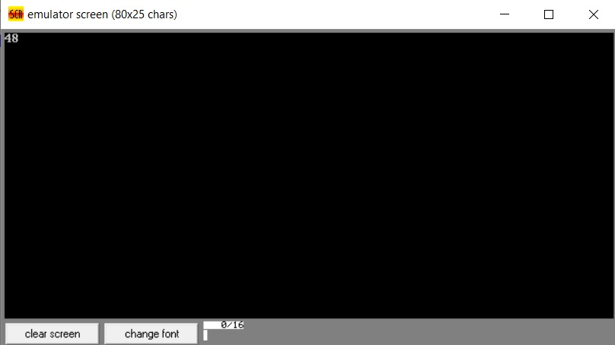

**Question:**

**Write a program in assembly language to perform multiplication of 16-bit data.**

**CODE:**

**org 100h**

**mov ax, 0012h**

**mov bx, 0012h**

**mul bx**

**mov bx, ax**

**mov ah, bh**

**shr ah, 4**

**add ah, 30h**

**cmp ah, 39h**

**jle print_high_nibble**

**add ah, 7**

**print_high_nibble:**

**mov dl, ah**

**mov ah, 02h**

**int 21h**

**mov ah, bh**

**and ah, 0fh**

**add ah, 30h**

**cmp ah, 39h**

**jle print_low_nibble**

**add ah, 7**

**print_low_nibble:**

**mov dl, ah**

**mov ah, 02h**

**int 21h**

**mov ah, bl**

**shr ah, 4**

**add ah, 30h**

**cmp ah, 39h**

**jle print_high_nibble2**

**add ah, 7**

**print_high_nibble2:**

**mov dl, ah**

**mov ah, 02h**

**int 21h**

**mov ah, bl**

**and ah, 0fh**

**add ah, 30h**

**cmp ah, 39h**

**jle print_low_nibble2add ah, 7**

**print_low_nibble2:**

**mov dl, ah**

**mov ah, 02h**

**int 21h**

**mov ah, 4Ch**

**int 21h**

**OUTPUT:**

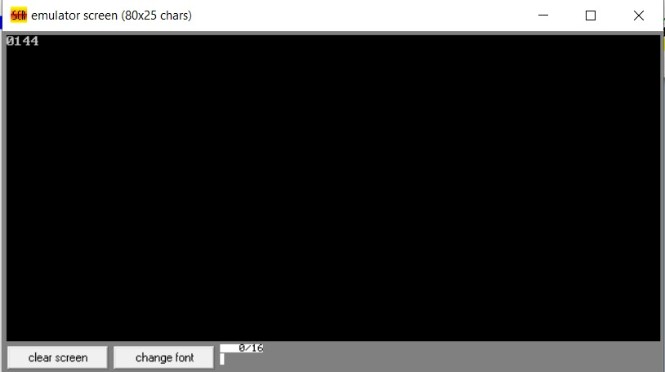

**GITHUB:**

[**https://github.com/srijachakilam15/COA/blob/main/lab%20practical%2003.docx**](https://github.com/srijachakilam15/COA/blob/main/lab%20practical%2003.docx)